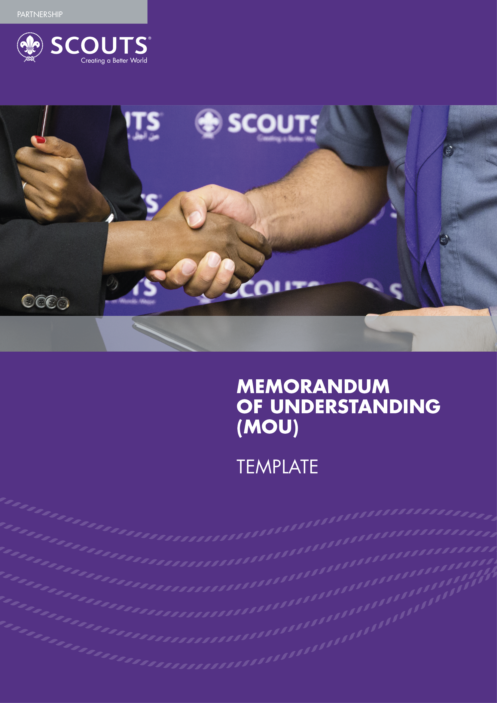


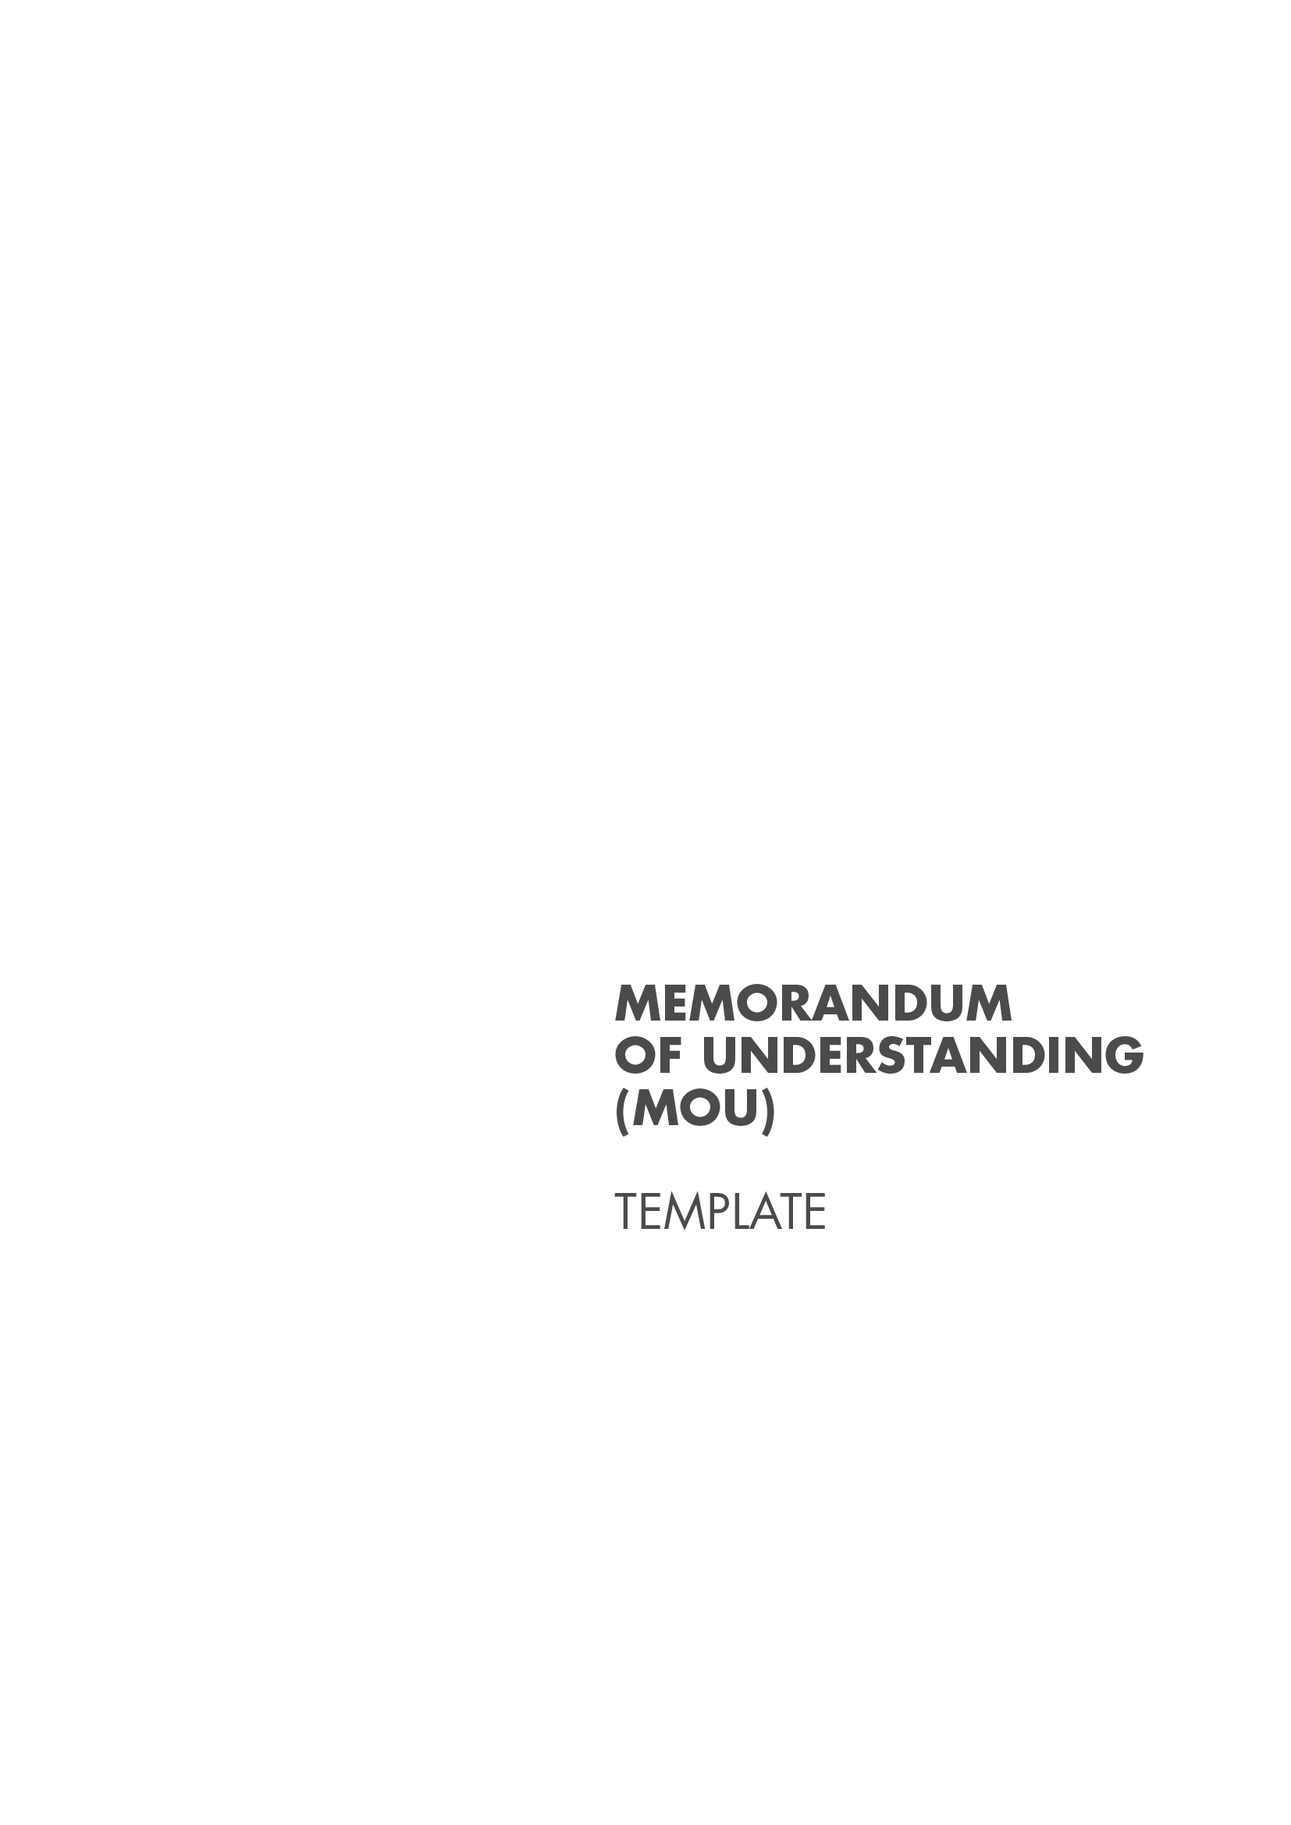

This Memorandum of Understanding (MoU) Template serves to provide guidance for National Scout Organizations (NSOs) seeking to formalise potential or existing partnerships. In this template you will first find a blank version of the MoU template, followed by a sample template that is already filled in with information.

This MoU template is merely an example of how an MoU can be structured. The provisions of each agreement depend on the type of partnership and local laws. Some partners may ask that you use their standard tempalates, which is acceptable as long as you pay close attention to the articles and make sure it is largely in line with what is presented in this tempalte. NSOs should use their discretion to formulate context specific agreements.

NB:
- All text in plain black is standard text that we recommend not to be altered.
- All yellow highlighted text is sample content that may be adapted by the NSO to suit the context of each partnership.

NSO LOGO
PARTNER LOGO

MEMORANDUM OF UNDERSTANDING
BETWEEN
PARTNER ORGANISATION
AND
National Scout Organization

This Memorandum of Understanding (“MoU”) is entered into by PARTNER, PARTNER REGISTRATION INFORMATION and National Scout Organization (NSO), a Member Organization of the World Organization of the Scout Movement (WOSM) and having its office at ADDRESS OF OFFICE and reigstered under the laws of COUNTRY OF LEGAL REGISTRATION. NSO and Partner are henceforth referred to as the “Parties” and each independently as a “Party”.

WHEREAS, ENTER AIM OF PARTNER ORGANISATION

WHEAREAS, NSO is a voluntary non-political educational movement currently comprised of XX Member Organizations (known as “National Scout Associations”) all over the country, representing XX total members with similar ideals of movement building, a global voice and an ability to engage younger audiences.

Both parties recognise their mutual obligation to cooperate with each other to ensure ENTER THEMES OF COLLABORATION. The parties have met and conferred in good faith regarding ENTER SHARED OBJECTIVES. Both Parties recognise rights-based, age, gender, diversity, as well as community-based approaches as central to their collaboration.

NOW, THEREFORE, the Parties in the commencement of this partnership agree to cooperate as follows:

ARTICLE 1
PURPOSE AND SCOPE

The purpose of this MoU is to provide a framework of cooperation and to facilitate collaboration between the Parties in their areas of common interest.

The Parties have similar objectives with regards to ENTER SHARED OBJECTIVES.

In this MoU, the Parties will collaborate efforts to achieve their shared and common objectives in the field of LIST THE THEMES OF COOPERATION.

ARTICLE 2
AREAS OF COOPERATION

The Parties do hereby agree to cooperate in the following areas:

- Technical support in development of …….. concerning the subject of initiatives implemented guided by this MoU;
- Event support and mutual support in events related to the Parties’ scope of cooperation;
- Where available, financial support related to the provision of……….;
- Collaborate to promote ……….;
- Host joint events to ……. through organising joint communications, events and activities;
- Advocate for government policy frameworks that ……………..;
- Technical support related to ……….. ;
- Networking and a creation of a community of relevant stakeholders through stakeholder engagement;

PARTNER agrees to provide the following activities or services:

NSO agrees to provide the following activites or services:

The areas of cooperation enlisted should not be taken to exclude or replace other forms of cooperation between the Parties on other issues of common interest as the list is not exhaustive. The Parties will develop joint ENTER FREQUENCY (YEARLY, QUARTERLY, ETC) work plans to operationalise this MoU.

ARTICLE 3
CONSULTATION AND EXCHANGE OF INFORMATION

  - The Parties will, on a regular basis, keep each other informed of and consult on matters of common interest, which in their opinion are likely to lead to mutual collaboration.

  - Consultation and exchange of information and documents under this Article shall be without prejudice to arrangements, which may be required to safeguard the confidential and restricted character of certain information and documents. Such arrangements will survive the termination of this MOU and of any agreements signed by the parties within the scope of this collaboration.

  - The Parties shall, at such intervals as deemed appropriate, convene meetings to review the progress of activities being carried out under the present MOU and to plan future activities.

  - The Parties may invite each other to send observers to meetings or conferences convened by them or under their auspices in which, in the opinion of either Party, the other may have an interest. Nothing in this sub-paragraph 3.4 shall be deemed to prejudice the established rules and procedures applying to such meetings and conferences. Invitations, if any, shall be subject to such rules and procedures.

ARTICLE 4
IMPLEMENTATION OF THE MOU

  - Is it understood that all activities under this MoU shall be subject to the rules, policies and procedures of the Parties. Any cooperation between the Parties under this MoU shall be on a non-exclusive basis.

  - This MoU will be operationalised through a detailed work plan, which will be developed within six months of signature.

Supplementary Agreements:

  - The Parties may conclude other supplementary agreements for the implementation of this MoU, as appropriate.

Other Matters:

  - Neither Party shall be an agent or representative of the other Party. Neither Party shall enter into any contract or commitment on behalf of the other Party and shall be soley responsible for making all payments to and on behalf of its own account, as provided under this MoU or any other agreement between the Parties.

  - Each Party shall be responsible for its acts and omissions in connection with this MoU and its implementation.

  - The parties agree to recognise and acknowledge their cooperation, as appropriate. To this end, the Parties shall consult with each other concerning the manner and form of such recognition and acknowledgement.

ARTICLE 5
USE OF NAME,EMBLEM AND LOGO

  - Neither Party shall use the name, logo, emblem or trademarks of the other party, or any its subsidiaries, or affiliates, or any abbreviation thereof, without the express prior written approval of the other Party in each case, unless otherwise provided in any supplementary agreement between the Parties.

  - Each Party acknowledges that it is familiar with other’s mandate and objectives and recognises that its name, logo and emblem may not be associated with any political or sectarian cause or otherwise used in a manner inconsistent with the status, reputation and neutrality of the other Party.

ARTICLE 6
DURATION AND TERMINATION

  - The proposed cooperation under this MoU is non-exclusive and will have an initial term from ENTER STARTING DATE to ENTER ENDING DATE, unless terminated earlier by either Party upon two months notice in writing to the other Party. The Parties may agree to extend this MoU in writing for subsequent periods.

  - Termination of this MoU will not affect any other agreements relating to the subject matter of this MoU which will, unless terminated or expired, continue to regulate the relationship between the Parties in accordance with the terms thereof.

ARTICLE 7
AMENDMENT

  - Either Party may request to make amendments to this MoU.

  - This MoU may be amneded only by mutual written consent of the Parties.

  - Any amendments to this MoU shall be deemed to take effect upon the execution and signature of all Parties.

ARTICLE 8
REPRESENTATIONS

  - NSO represents that it is an organisation in good standing duly organised under the World Scout Constitution and other relevant WOSM policies.

ARTICLE 9
CODE OF CONDUCT

  - The Parties commit to carrying out all their activities with the highest ethical and professional standards, both within their respective organisations and externally, in conformity with the Convention on the Rights of the Child.

  - Both parties operate on principles of zero tolerance to all forms of abuse, including sexual exploitation and abuse (SEA), and agree to collaborate in prevention, protection from, and all forms of abuse in line with the ENTER PARTNER POLICY ON PROTECTION FROM ABUSE and WOSM’s Safe from Harm Policy.

ARTICLE 10
FUNDING

  - The Parties agree that all financial arrangements between the Parties should be further negotiated and mutually agreed upon and will depend on the availability of funds.

  - The Parties may seek financing of joint activities from internal and external sources available to them.

  - Neither Party shall engage in fundraising with third parties in the name of or on behalf of the other, without the prior express written approval of the other Party in each case.

ARTICLE 11
ENTRY INTO EFFECT

This MOU shall enter into effect on the date it is signed by both Parties.

IN WITNESS WHEREOF, the duly authorised representatives of the Parties affix their signatures on the date stated below.

For the Partner

Name:

Signature: __________
Date:
For the NSO

Name:

Signature: ___________
Date:

NSO LOGO
PARTNER LOGO

MEMORANDUM OF UNDERSTANDING
BETWEEN
The Rainbowland Association for Persons with Disabilities (RAPD)
AND
The Rainbowland Scout Federation (RSF)

This Memorandum of Understanding (“MoU”) is entered into by the Rainbowland Association for Persons with Disabilities (RAPD), registered under the laws of Rainbowland and having its offices at 123 Rainbow Road, Rainbow City, and the Rainbowland Scout Federation (RSF), a Member Organization of the World Organization of the Scout Movement (WOSM), registered under the laws of Rainbowland and having its office at 1907 Brownsea Road, Rainbow City. RAPD and RSF are henceforth referred to as the “Parties” and each independently as a “Party”.

WHEREAS, RAPD is the leading non-governmental organisation in Rainbowland defending the rights of persons with disabilities and actively supporting them to achieve their full potential.

WHEAREAS, RSF is a voluntary non-political educational movement currently comprised of 4 Member Organizations (known as “National Scout Associations”) all over the country, representing 82,000 total members with similar ideals of movement building, a global voice and an ability to engage younger audiences.

Both parties recognise their mutual obligation to cooperate with each other to ensure young people with disabilities are actively supported as full members of the Scout Movement in Rainbowland. The parties have met and conferred in good faith regarding expanding RSF’s inclusion initiatives and infrastructure. Both Parties recognise rights-based, age, gender, diversity, as well as community-based approaches as central to their collaboration.

NOW, THEREFORE, the Parties in the commencement of this partnership agree to cooperate as follows:

ARTICLE 1
PURPOSE AND SCOPE

The purpose of this MoU is to provide a framework of cooperation and to facilitate collaboration between the Parties in their areas of common interest.

The Parties have similar objectives with regards to ensure young people with disabilities are actively supported as full members of the Scout Movement in Rainbowland

In this MoU, the Parties will collaborate efforts to achieve their shared or common objectives in the field of the inclusion and active participation of young people with disabilities.

ARTICLE 2
AREAS OF COOPERATION

The Parties do hereby agree to cooperate in the following areas:
- Inclusive non-formal education programmes for young people with disabilities;
- Policy advocacy related to the rights of people with disabilities;
- Joint communications campaigns promoting the rights of people with disabilities.

RAPD agrees to provide the following activities or services:
- Technical support in development of a Scout badge in the area of diversity and inclusion;
- Support in ensuring all physical and institutional infrastructure and policies in RSF is friendly to young people with disabilities;
- Support in expanding the Scout Youth Programme to actively reach out to young people with disabilities;
- Event support related to promoting the rights of young people with disabilities both externally and internally in the Scout Movement;
- Joint advocacy campaigns to encourage the national government policies of Rainbowland better support and defend the rights of people with disabilities.
- Provide trainings to RSF adult leaders and volunteers on disability inclusion before and while integrating new members with disabilities into Scout groups.

RSF agrees to provide the following activites or services:
- Implementation the joint badge through the Youth Programme of its four National Scout Associations;
- Review, update, and where necessary, create policies and infrastructure within the RSF to actively include young people with disabilities into the Scout Movement;
- Support RAPD’s advocacy work through the appointing of Scout youth ambassadors for people with disabilities;
- Expand the Scout Youth Programme and actively reach out to young people with disabilities and include them in existing Scout groups;
- Require training for RSF adult leaders and volunteers on disability inclusion before and while integrating new members with disabilities into Scout groups.

The areas of cooperation enlisted should not be taken to exclude or replace other forms of cooperation between the Parties on other issues of common interest as the list is not exhaustive. The Parties will develop joint yearly work plans to operationalise this MoU.

ARTICLE 3
CONSULTATION AND EXCHANGE OF INFORMATION

  - The Parties will, on a regular basis, keep each other informed of and consult on matters of common interest, which in their opinion are likely to lead to mutual collaboration.

  - Consultation and exchange of information and documents under this Article shall be without prejudice to arrangements, which may be required to safeguard the confidential and restricted character of certain information and documents. Such arrangements will survive the termination of this MOU and of any agreements signed by the parties within the scope of this collaboration.

  - The Parties shall, at such intervals as deemed appropriate, convene meetings to review the progress of activities being carried out under the present MOU and to plan future activities.

  - The Parties may invite each other to send observers to meetings or conferences convened by them or under their auspices in which, in the opinion of either Party, the other may have an interest. Nothing in this sub-paragraph 3.4 shall be deemed to prejudice the established rules and procedures applying to such meetings and conferences. Invitations, if any, shall be subject to such rules and procedures.

ARTICLE 4
IMPLEMENTATION OF THE MOU

  - Is it understood that all activities under this MoU shall be subject to the rules, policies and procedures of the Parties. Any cooperation between the Parties under this MoU shall be on a non-exclusive basis.

  - This MoU will be operationalised through a detailed work plan, which will be developed within six months of signature.

Supplementary Agreements:

  - The Parties may conclude other supplementary agreements for the implementation of this MoU, as appropriate.

Other Matters:

  - Neither Party shall be an agent or representative of the other Party. Neither Party shall enter into any contract or commitment on behalf of the other Party and shall be soley responsible for making all payments to and on behalf of its own account, as provided under this MoU or any other agreement between the Parties.

  - Each Party shall be responsible for its acts and omissions in connection with this MoU and its implementation.

  - The parties agree to recognise and acknowledge their cooperation, as appropriate. To this end, the Parties shall consult with each other concerning the manner and form of such recognition and acknowledgement.

ARTICLE 5
USE OF NAME, EMBLEM AND LOGO

  - Neither Party shall use the name, logo, emblem or trademarks of the other party, or any its subsidiaries, or affiliates, or any abbreviation thereof, without the express prior written approval of the other Party in each case, unless otherwise provided in any supplementary agreement between the Parties.

  - Each Party acknowledges that it is familiar with other’s mandate and objectives and recognises that its name, logo and emblem may not be associated with any political or sectarian cause or otherwise used in a manner inconsistent with the status, reputation and neutrality of the other Party.

ARTICLE 6
DURATION AND TERMINATION

  - The proposed cooperation under this MoU is non-exclusive and will have an initial term from 14 January 2022 to 14 January 2025, unless terminated earlier by either Party upon two months’ notice in writing to the other Party. The Parties may agree to extend this MoU in writing for subsequent periods.

  - Termination of this MoU will not affect any other agreements relating to the subject matter of this MoU which will, unless terminated or expired, continue to regulate the relationship between the Parties in accordance with the terms thereof.

ARTICLE 7
AMENDMENT

  - Either Party may request to make amendments to this MoU.

  - This MoU may be amneded only by mutual written consent of the Parties.

  - Any amendments to this MoU shall be deemed to take effect upon the execution and signature of all Parties.

ARTICLE 8
REPRESENTATIONS

  - NSO represents that it is an organisation in good standing duly organised under the World Scout Constitution and other relevant WOSM policies.

ARTICLE 9
CODE OF CONDUCT

  - The Parties commit to carrying out all their activities with the highest ethical and professional standards, both within their respective organisations and externally, in conformity with the Convention on the Rights of the Child.

  - Both parties operate on principles of zero tolerance to all forms of abuse, including sexual exploitation and abuse (SEA), and agree to collaborate in prevention, protection from, and response to all forms of abuse in line with the RAPD’s policy for the protection of young people with disabilities and WOSM’s Safe from Harm Policy.

ARTICLE 10
FUNDING

  - The Parties agree that all financial arrangements between the Parties should be further negotiated and mutually agreed upon and will depend on the availability of funds.

  - The Parties may seek financing of joint activities from internal and external sources available to them.

  - Neither Party shall engage in fundraising with third parties in the name of or on behalf of the other, without the prior express written approval of the other Party in each case.

ARTICLE 11
ENTRY INTO EFFECT

This MOU shall enter into force on the date it is signed by both Parties.

IN WITNESS WHEREOF, the duly authorised representatives of the Parties affix their signatures on the date stated below.

For the Partner

Name:

Signature: __________
Date:

For the NSO

Name:

Signature: ___________
Date:



